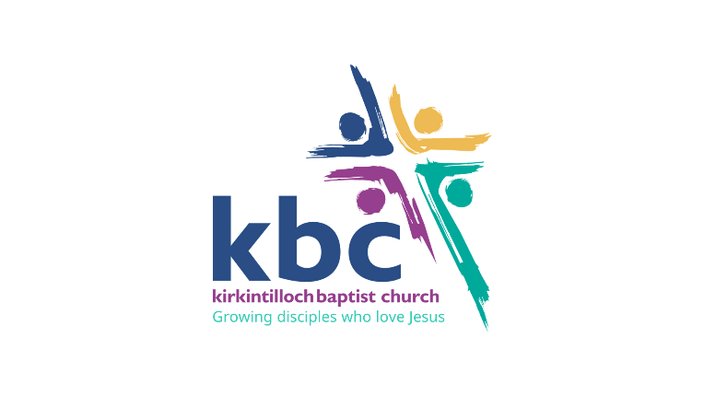
Youth Pastor

Responsible to: Lead Pastor
Contract: Full time

Overview
KBC are seeking a Youth Pastor who is gifted in and is called to church ministry, with a pastoral heart for the younger generation and a passion for shepherding young people within a multi-generational congregation. They have a love for Jesus Christ and desire to proclaim the Word of God with conviction and confidence, always building relationships and connections to enable our youth and young adults to move towards taking consistent spiritual steps. They will walk alongside young people and invest in them pastorally. They can set a vision and empower others. They live out the Great Commission by sharing the gospel boldly, by journeying with the younger generation, and through a passion for discipleship and making disciples.

High level Role Description
Consequently, we seek a Youth Pastor to join our ministry team who has a heart for caring for and discipling our younger generations with a focus on youth (12-18) and young adults (19-25) within our church and wider community through outreach.

Who
- provides effective leadership to the Youth Ministry Team and our Children’s and Families Ministry Leader.
- builds relationships with our current youth and young adults but also has a desire to see those outside church life come and experience God.
- oversees the pastoral care of the young people and meets with them one to one as necessary.
- brings a focus to our Sunday evening service for the youth and young adults.
- through preaching and teaching, will explain Christian truths, encourage biblical attitudes, inspire application, and spur the younger generation on to become more like Jesus.
- actively supports the children’s team and works with them to ensure a smooth transition from being a child to a young adult within our congregation.
- participates in wider church events as appropriate e.g. Children’s Holiday Club, church weekends, Canal Festival, etc.

Essential
- a devotion to Jesus Christ and His purposes in the world
- a commitment to the local church/KBC
- a good role model and highly relational with a heart for people
- a heart for local outreach and an ability to equip young people for mission
- ability to disciple young people soundly
- in agreement with our core beliefs and values
- be both an excellent team player and a team leader
- effective planning skills
- awareness and appreciation of relevant safeguarding
- ability to communicate effectively with young people and teach in an engaging manner
- theological training and an ability to reflect theologically
- experience working with the under 25s
- demonstrated fruitfulness in youth ministry in a Christian context

Desirable
- visionary skills and an ability to think at a strategic level
- an accredited Baptist Minister
- musical gifting / ability to lead sung worship

1st Timothy 3 provides a wonderful guide as a qualification for our overseers.

